**~ The Church In Brielle ~**

**821 Riverview Dr. ~ Brielle, NJ, 08730**

**Weekly Announcements August 24, 2023**



[This Photo](https://epitemnein-epitomic.blogspot.com/2015/09/7-ways-to-pray-for-vulnerable.html) by Unknown Author is licensed under [CC BY-NC-ND](https://creativecommons.org/licenses/by-nc-nd/3.0/)

***Our thoughts and prayers are with the family and friends of Glenn Herb, who passed into God’s nearer presence. Glenn is Hilde’s son and Gail’s brother.***

**Join Us For Worship at 10:00 AM Sunday Mornings**

**In The CIB Sanctuary and Facebook Live**

**Concert at the Garden ~**

St. Denis Church in Manasquan

Hello All, We will be having a “Concert at the Garden” at St. Denis near the Ecumenical Giving Garden, on 30 August at 6:30pm.  All are invited for a relaxing evening of some music and fellowship under the full moon (or in the school in inclement weather).  Bring a lawn chair (if outside).  Park in the school lot and walk behind the Convent.  Fr. Bill, St. Denis

**First Friday Night Fire Pit:**

**September 1, 2023**



**Then, join us at 7:30 PM for a time of fun and fellowship for young and old at the Fire Pit! We will gather in the side yard. We will make smores, roast marshmallows and have a great time getting to know each other and having fun! We may break out in informal tossing a frisbee or two, sing, whatever. Please bring a chair, blanket or towel! And bring a friend.**



**The Church In Brielle Directory Project**

**It is time to create a church directory with pictures – and we need you!! We currently have a spreadsheet of names, addresses, telephone numbers, and email addresses that is somewhat functional. We want to make an easy access directory for all (online and print).**

**Two Requests: 1 – EVEN IF YOU THINK WE HAVE YOUR CORRECT INFORMATION…Complete the form at this link and upload your favorite individual or family photo – and submit.**

[**https://docs.google.com/forms/d/1UYVYPUvivIzLRHCcxJQv-yXprDTwZMNeOCpXajvqKI/edit?pli=1**](https://docs.google.com/forms/d/1UYVYPUvivIzLRHCcxJQv-yXprDTwZMNeOCpXajvqKI/edit?pli=1)

**2 - Let us know if you would like to work on compiling the information as it is submitted. We are using Google Forms to gather the info - open to how to organize and print / post.**

**Have ideas or time to help? Contact Shannon Nish at** [**shannonscott11@gmail.com**](mailto:shannonscott11@gmail.com) **or Lori Keasel at** [**lorik86@gmail.com**](mailto:lorik86@gmail.com)



**Monthly First Sunday Fellowship Feast**

**Fellowship Hour is really awesome any Sunday and we want to continue to make Communion Sunday an extra special spread. We can make this happen with a group effort.**

**Mark your calendars and remember to bring a special dish of any kind.**

**Thank you always for your gracious support.**

**PS we always need helpers for clean-up. Many hands make light work.**

**Watch for our “CARD CORNER” in Fellowship Hall and sign a card for those who can’t be with us and could use a cheery hello.**

**We love our church family!**

**The Fellowship Committee**

**Brielle Day**

**September 9, 2023**

**Brielle Park**

**9:00 AM – 4:00 PM**



The Church In Brielle Will:

* Display Posters Of All The Missions We Are Doing In The Community, State And World
* Make And Give Away Donuts And Coffee
* Host A Crafts Table For Kids
* Be A Friendly Representation Of The Church
* Offer Opportunities For People To Make Donations To Support Missions.

Please Sign Up In Fellowship Hall For An Hour Or Two Time Slot(s) To Be Present At Our Tent:

* To Make Donuts (Easy Toaster Like Maker)
* Serve Coffee
* Help With Crafts Table
* Say Hi!

**The Church in Brielle Women's Guild**

**The Church in Brielle Women's**

**Guild will be meeting directly after Sunday service on Sunday, August 27, 2023.  We will be discussing, among other things, our upcoming Jewelry Sale and Coffee House in October to raise support for Cypress Missions.**

**Thank you,  Joan Leavitt – Chairperson**

**Gentle Meditative Yoga Time:**

**Will Resume In September**



**Qi Gong Is Back!**

**With Deborah Kehoe**

**Each Wednesday in June and July,**

**5:15 – 6:00 PM**

**Classes are $8.00.**

**For more information, please see our Qi Gong Instructor, Debbie Kehoe’s website.** [**https://www.mindfulnessmovementmusic.com**](https://www.mindfulnessmovementmusic.com/)

**Sunday School For Kids Begins Sunday,**

**September 10th!**

**Cypress Missions:**

Lebanon, Pa: Gretna Glen Conference Center

Aug 21 - Aug 25

Work projects will vary from painting, demolition and building. This can be a family trip as well as training time for those interested in future locations.



**Ways to Give:**

* Place your offering in one of the offering plates in the sanctuary
* Mail in check
* Arrange with your bank to mail in a check
* Vanco Mobile Faith Engagement
* Coming soon – donate button on new website



**September 3rd is**

**Communion Sunday:**

**Virtual worshipers at home, please gather the elements of the Sacrament, the bread and the juice, before worship and we will consecrate all the elements together and feast at Jesus’ table. Celebrate the real presence of the Risen Christ!**

**MISSION OF THE QUARTER:**

**Caring For The House Of The Lord**



For the months of July through September we will be having our annual

***Caring and Repairing the House of the Lord*** Campaign

to raise the funds needed for several projects to keep our church safe, up to code, and beautiful. If you haven’t received a letter in the mail with a special envelope for this offering, please see extra copies and envelopes in

Fellowship Hall and in the back of the sanctuary.

Yours in Christ! The Administration Ministry.



***Plumpy Nut Ongoing …***

We have resumed collecting money for ***Plumpy Nut***!!! Each $1.50 worth of nutrition rich nut-based food bars (3 packets) provides a days’ worth of nourishment and calories for a child.

***Plumpy Nut*** is sweeping the world and can literally eliminate child hunger in the whole world in 2 decades!

**LOCAL FOOD PANTRY NEEDES:**

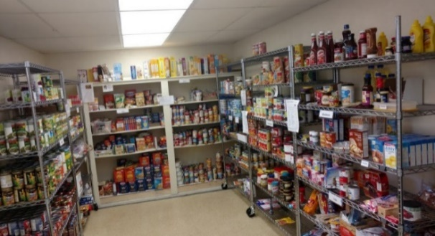

**MANASQUAN MINISTERIUM FOOD PANTRY:**

The dog days of summer are here. Not only does the pantry try to provide nutritious food for our families, but also for their pets. We have been low on both dog and cat food. Other items that quickly disappear from our shelves are canned black beans, pasta and pasta sauce, apple juice and applesauce. Nonfood items such as dish detergent, soap, shampoo, paper products etc. Many thanks to everyone who has been donating the much-needed items which are listed here monthly. Thanks also to those home gardeners who have been sharing their harvest with us! It’s a wonderful addition to offer!

Pantry hours are Monday and Tuesday 10:00-1:00 and Thursday and Friday 1:00-4:00 or nonperishable items may be left in the outside bin at the parking lot entrance to First Presbyterian.

Always appreciated are monetary donations and gift cards for Aldi or ShopRite to help with necessary purchases that may not be available from Fulfill. Thank you for remembering those families new to the pantry and those who are now visiting us more frequently.

**Easy Ways To Support Missions And Acts Of Caring For Others:**

**Collection of School Supplies**

**for Immigrant Children**

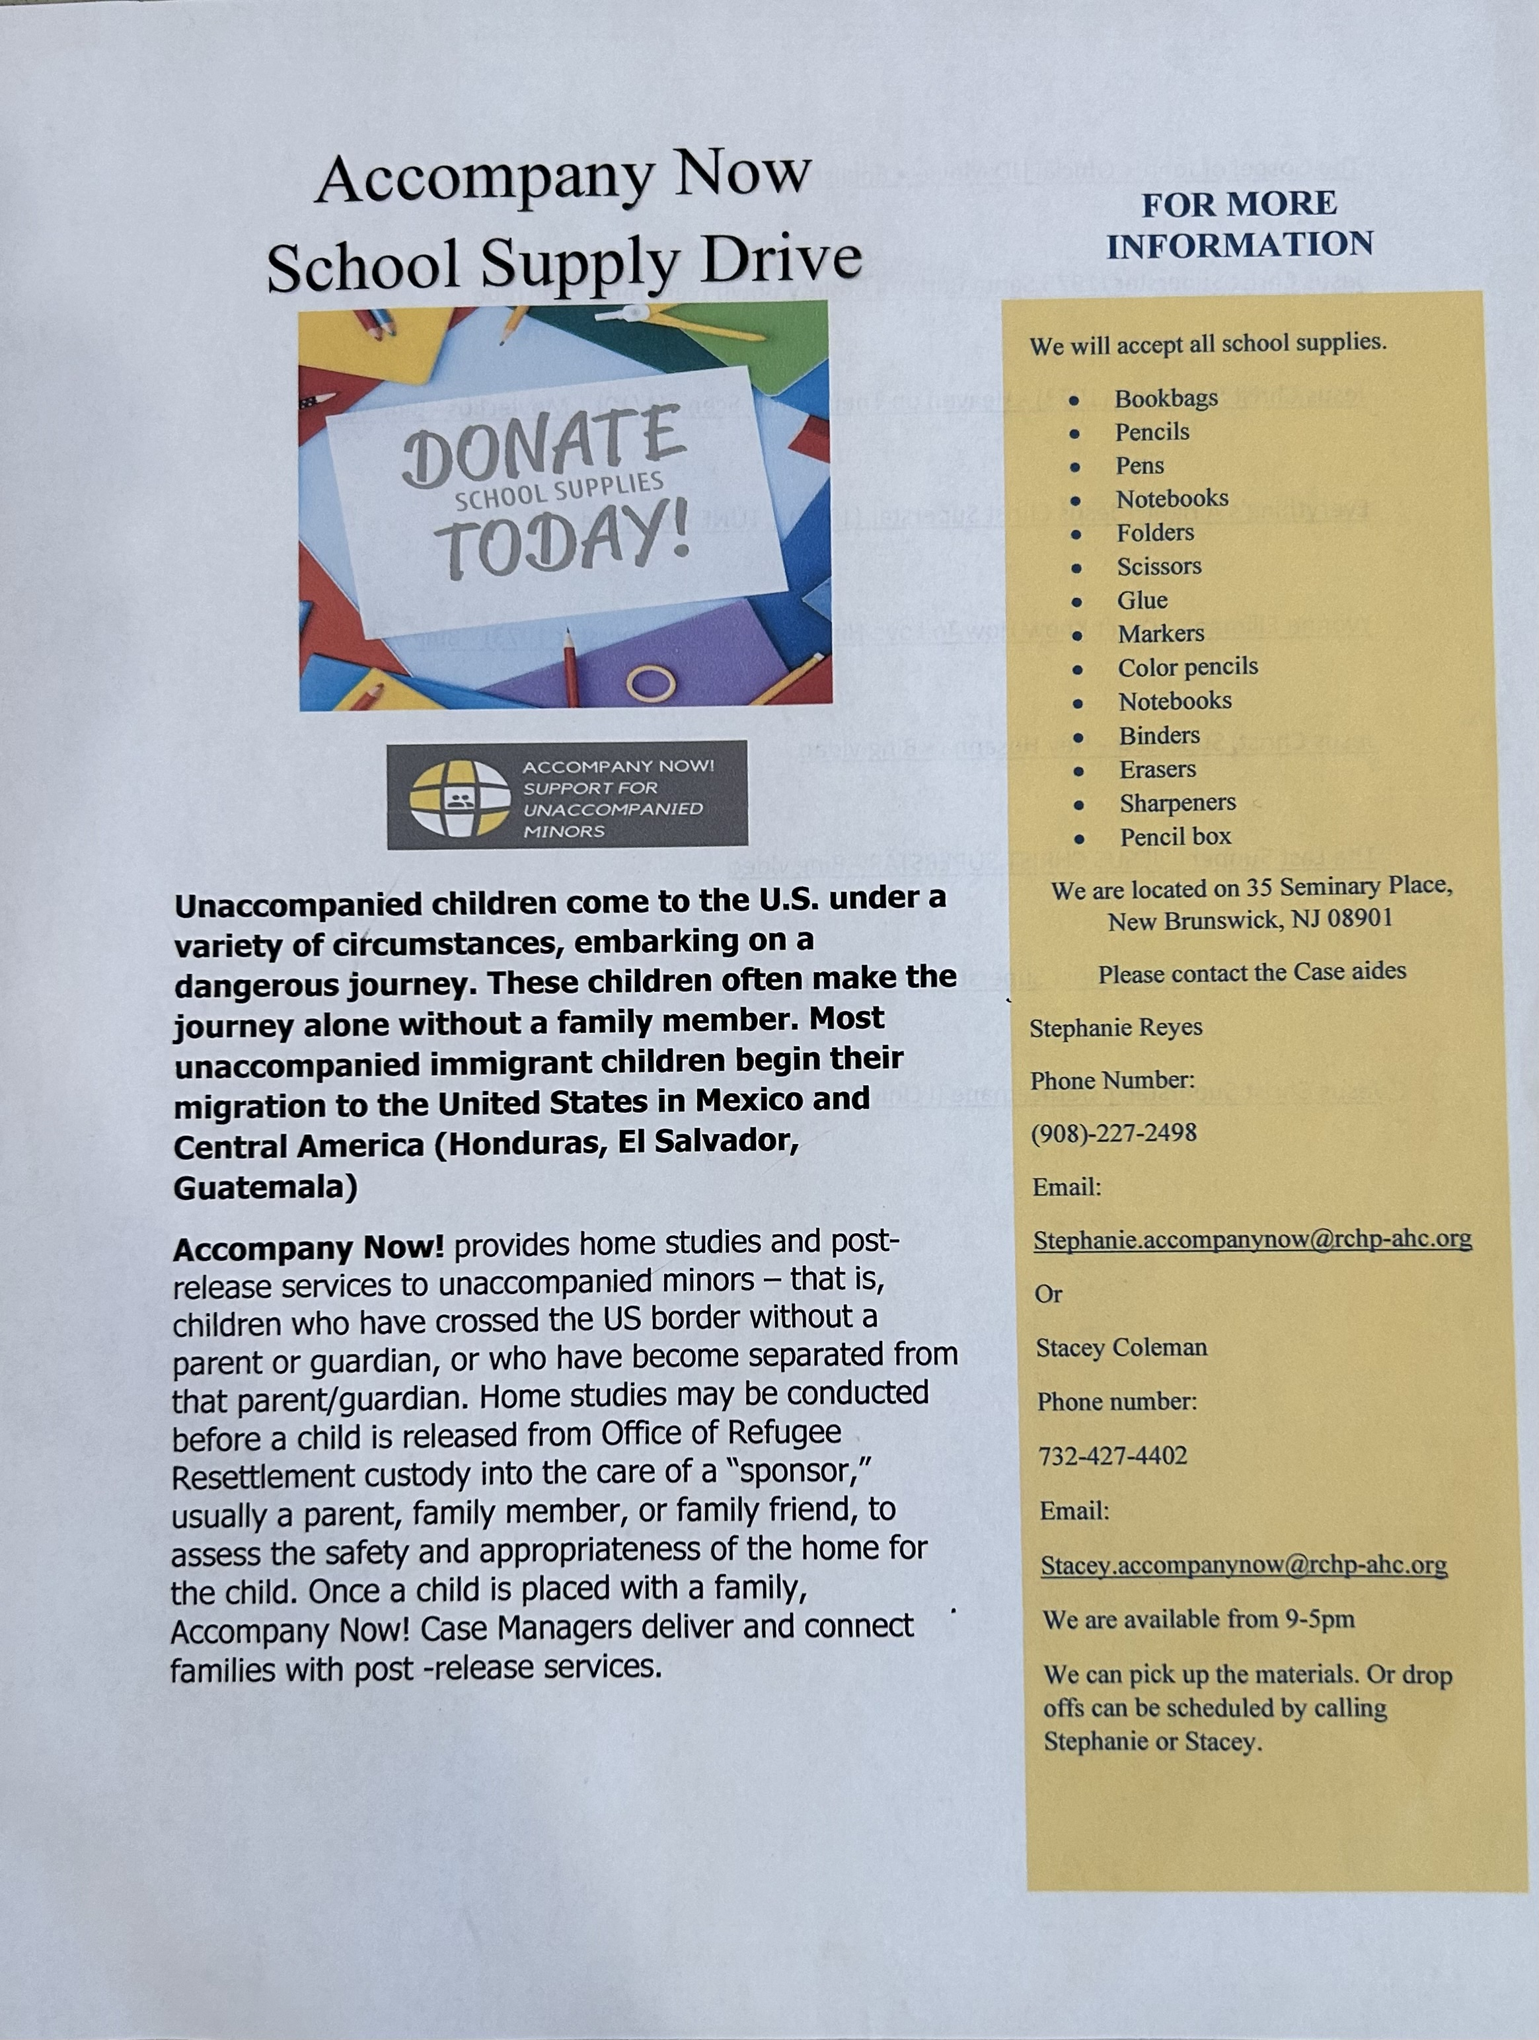

**DO YOU WORSHIP WITH US MOSTLY REMOTELY????**

**Worshiping with us on Facebook Live?**

**You are important to us! Please let us know who you are, your contact information, and any questions you have.**

**Worshiping with us on Facebook Live?**

**Let us know how you would complete the following…**

**\* The greatest need of my community is…**

**\* My greatest need is…**

**And be sure to give us your approximate age for our survey results.**



**Daily Devotions:**

**Weaving scripture and prayer, these short – n – sweet devotions are a great way to begin or end your day! They are usually based on the previous Sunday’s sermon.**

**Find them in your emails each day! If you are not receiving these daily inspirational messages email** [**pastorlou@churchinbrielle.org**](mailto:pastorlou@churchinbrielle.org)**.**

**Employment Opportunities – Perfect For People Seeking Employment And Making A Difference In People's Lives!**

**North, Central and South New Jersey!**

Hi Friends,

As many of you know, the Reformed Church of Highland Park Affordable Housing Corporation has grown dramatically over the past couple of years.  We are proud of the work that is occurring through the programs that live under this 501c3, programs like Interfaith-RISE, Still Waters Anti Trafficking, ReEntry Housing, Asylum Seeker Housing, Global Grace Health and Accompany Now.

Our staff is growing, but in no arena are we growing faster, right now, than in our program for Unaccompanied Minors.  There is a huge need to meet in NJ, and our funding has increased from a team of 8 to a team of 38 in a 6 month period.  We have not yet filled all our positions.

We are looking for excellence in Spanish/English, a college degree and some experience in the helping professions.  Some of the jobs we are filling require years of experience, and an MSW, but others do not need that high a level of experience and education.

We have positions open in Jersey City, in Trenton, in Vineland and, due to the fact that we are serving youth all over the state, we can hire people from all over the state.  2-days a week staff will be required to be in the office nearest to them, but the other three days are spent in client homes and helping with the requirements of the program (school registration, legal consultations, mental health support, benefits, health care sign up).

Please take a look at the listings here:   <https://rchp-ahc.org/employment-opportunities/>

We are hiring NOW and seeking your help in finding good candidates.

Peace, Seth Kaper-Dale,

Highland Park Reformed Church

**Joys, Gratitude & Concerns And Prayer**

**Please share your joys - births, birthdays, anniversaries, graduations –**

**and concerns - pictures are welcome!  Contact Pastor Lou at** [**pastorlou@churchinbrielle.org**](mailto:pastorlou@churchinbrielle.org)

**Do not worry about anything, but in everything by prayer and supplication with thanksgiving let your requests be made known to God. And the peace of God, which surpasses all understanding, will guard your hearts and your minds in Christ Jesus.**  Philippians 4:6-7

Our thoughts and prayers are with the family and friends of Glenn Herb, who passed into God’s nearer presence. Glenn is Hilde’s son and Gail’s brother.

Our thoughts and prayers are with the family and friends of Laura French, who passed into God’s nearer presence. Laura is JayneEllen and Tony Lanni’s friend.

Our thoughts and prayers are with the family and friends of Fiona Athey, who passed into God’s nearer presence. Fiona is Joy Wallis’ friend and sister-in-law.

Our thoughts and prayers are with the family and friends of Patty Nordling, a friend of Cynthia Farley, who passed into God’s nearer presence.

Our thoughts and prayers are with the family and friends of Rick Niau, who passed into God’s nearer presence. Rick is married to Jayne (Heinze) and is the son-in-law and brother-in-law of Mark and Marlyn Heinze & Jeff Heinze, respectively.

**Prayer Concerns:**

Lynn Lynch (Hospice)

Billy Musto

Bobby Bal

Neil Hamilton

Jeniene Stango

Mark Heinze

Raymond Salerno

Eddie Edwards

Glenn Zadroga

Al Olesky

Eddie Edward’s Parents

Jean Hyrinkawitz

Trisha Reo

Marilyn (Linfante) Eisser

Russel Wester

Carl Flohs

Jeff Huber

Beverly Hoffman

John and the Oswald Family

Candace Moose

Gerald Morie

Marcy VanZile

Dr. Bob & Joanne Evans

Pat Stefan

Henrietta Kiser Fox

Holden Messler (7)

Betsy Ewertsen

Rodney Thomas

Vincent Higginbotham

Bob and Patty Grover

Beth Sauerbrey

Jayne Linfante

Mary Ann Rowe

Addison, the

Wohltman’s niece

James Bitzer (3)

Olivia Cole

Vivian T Alston

June Parrott

Geraldine (Gerry) Ciullo,

sister of Rosemarie Pagliuca

Masie DePalma, Leslie

Duerr’s mom

Janet Derisi

Andrea Huber

Maui, Hawaii